**CSS**

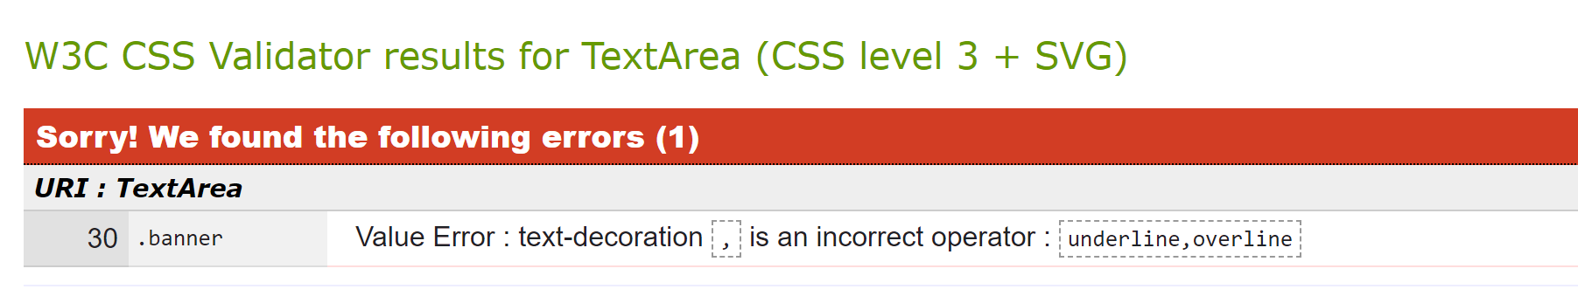

This is what came up after testing my CSS Code for the first time

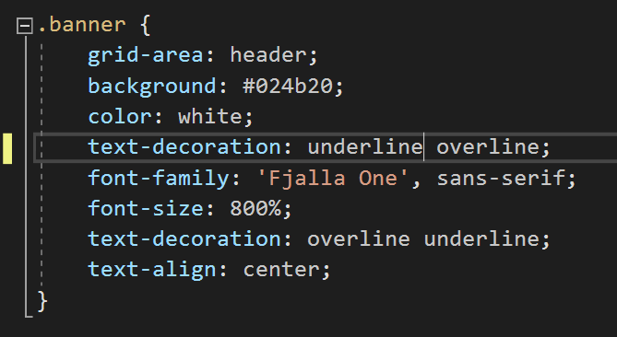After removing the comma from the Banner code, I got the results I was looking for:

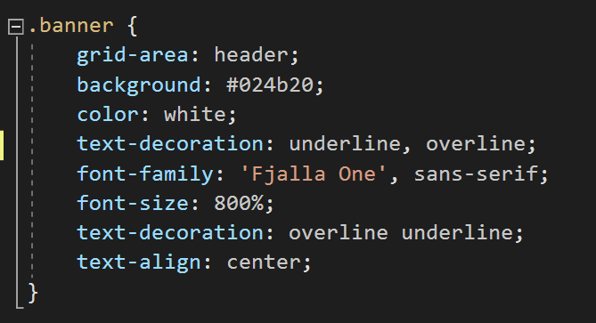



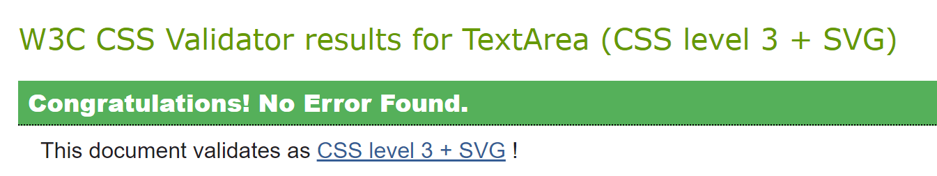

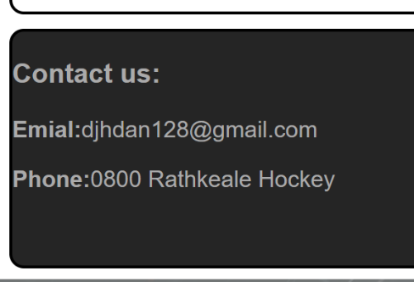**HTML**

I spelt Email wrong so I do fix.

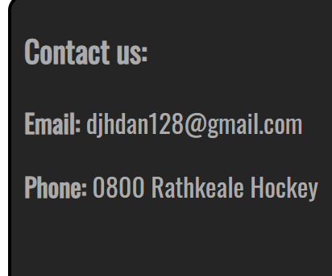

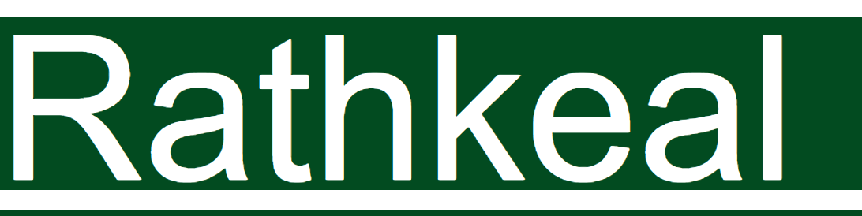

Spelt wrong



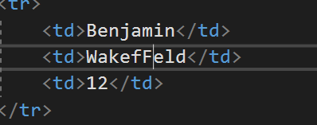

I spelt his name wrong

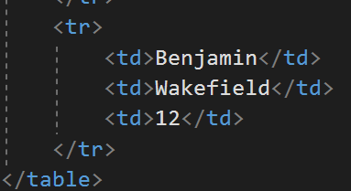

**Index**

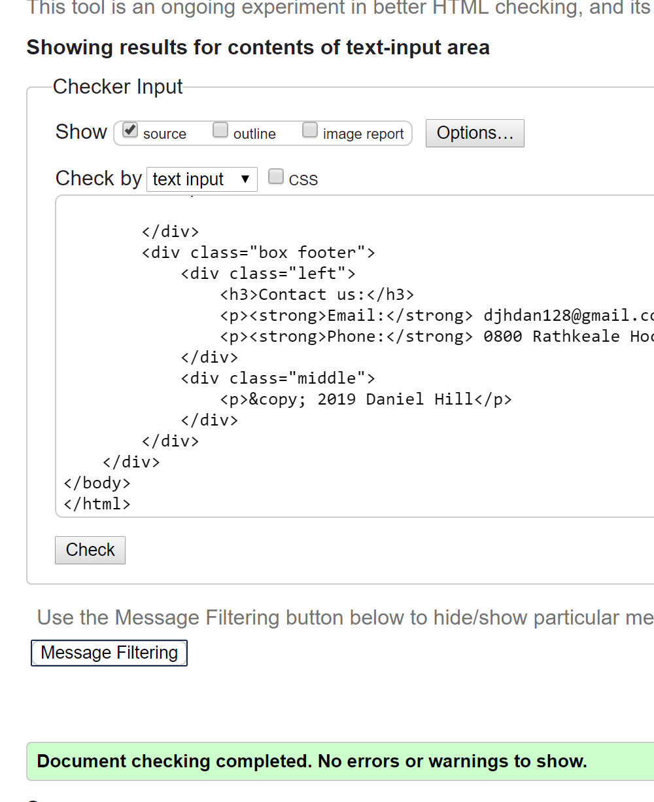

Ran text through Grammarly and it said that it is A ok. 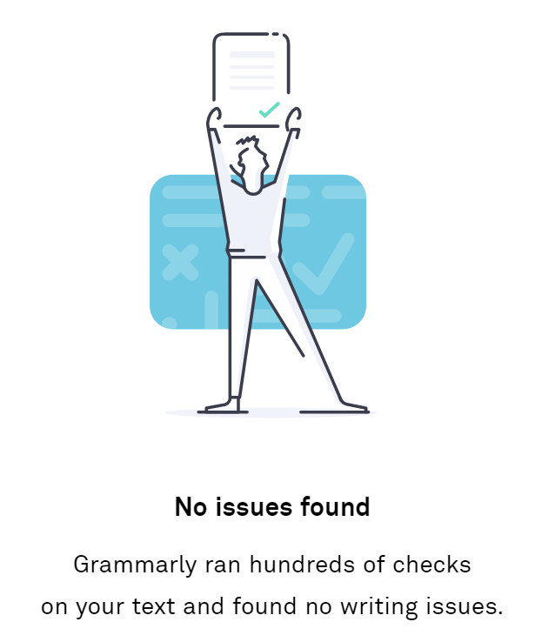

**2nd** XI

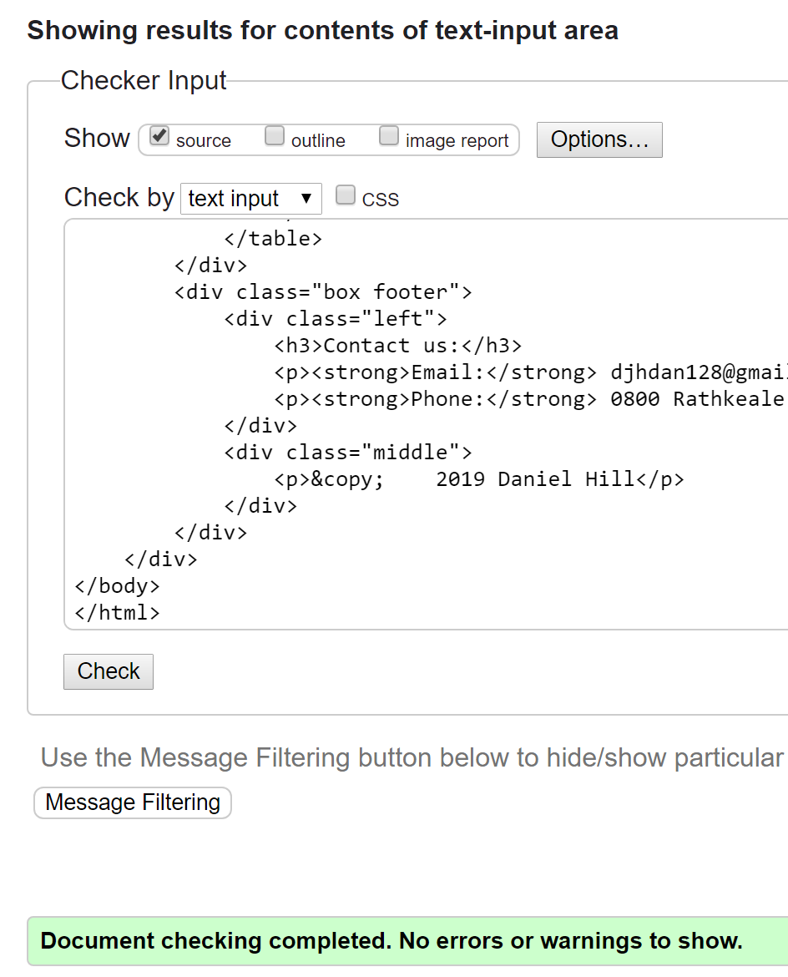

Ran text through Grammarly and it said that it is A ok. 

1st XI

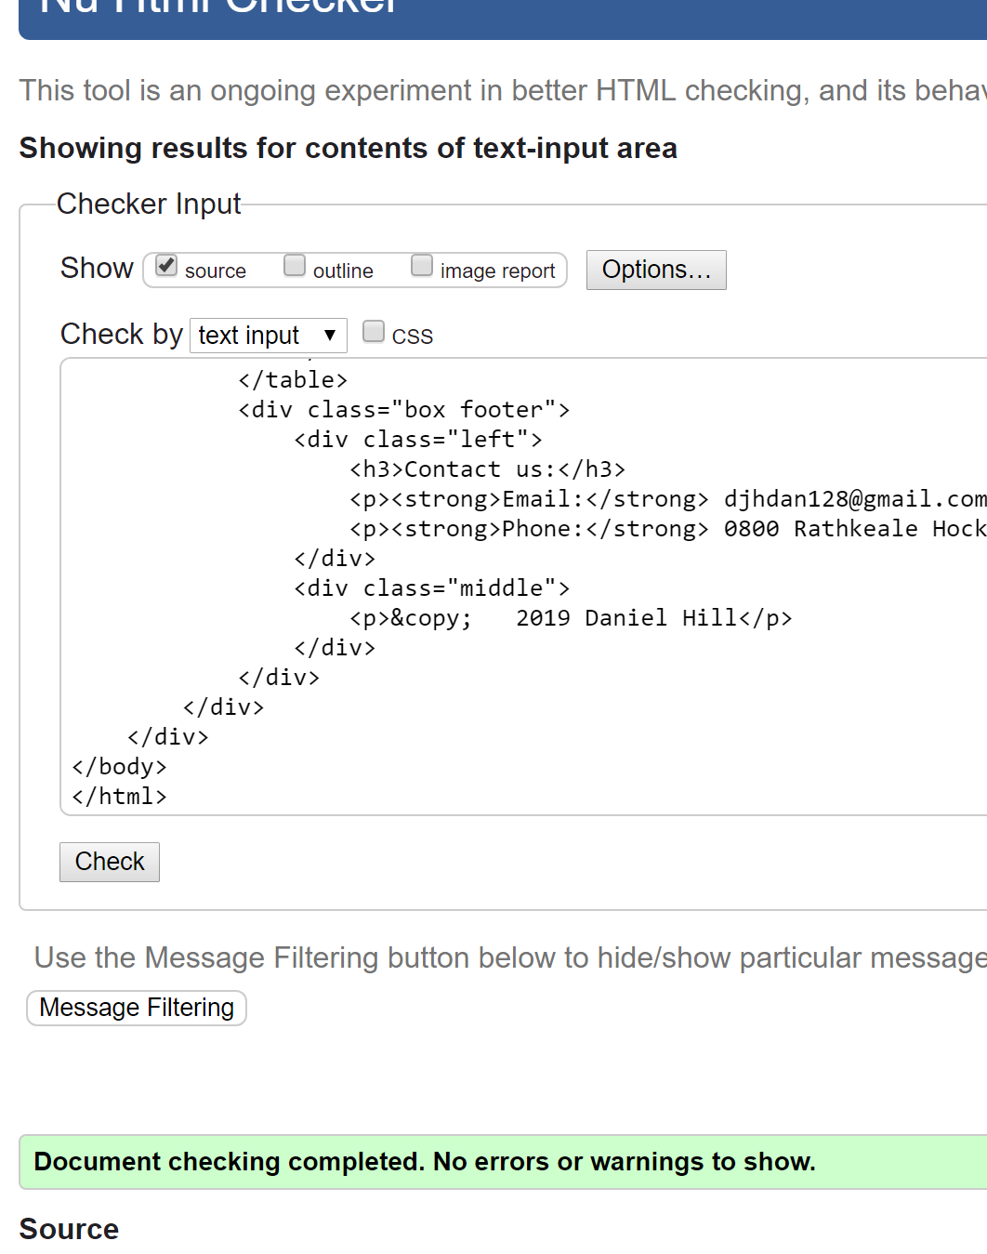

Ran text through Grammarly and it said that it is A ok. 

Rams hockey

Ran text through Grammarly and it said that it is A ok. 



Pioneer Hockey

Ran text through Grammarly and it said that it is A ok. 



Crux

Ran text through Grammarly and it said that it is A ok. 



Senior College



Ran text through Grammarly and it said that it is A ok. 

Contact us page



Ran text through Grammarly and it said that it is A ok. 

3 different web browsers:

Chrome: 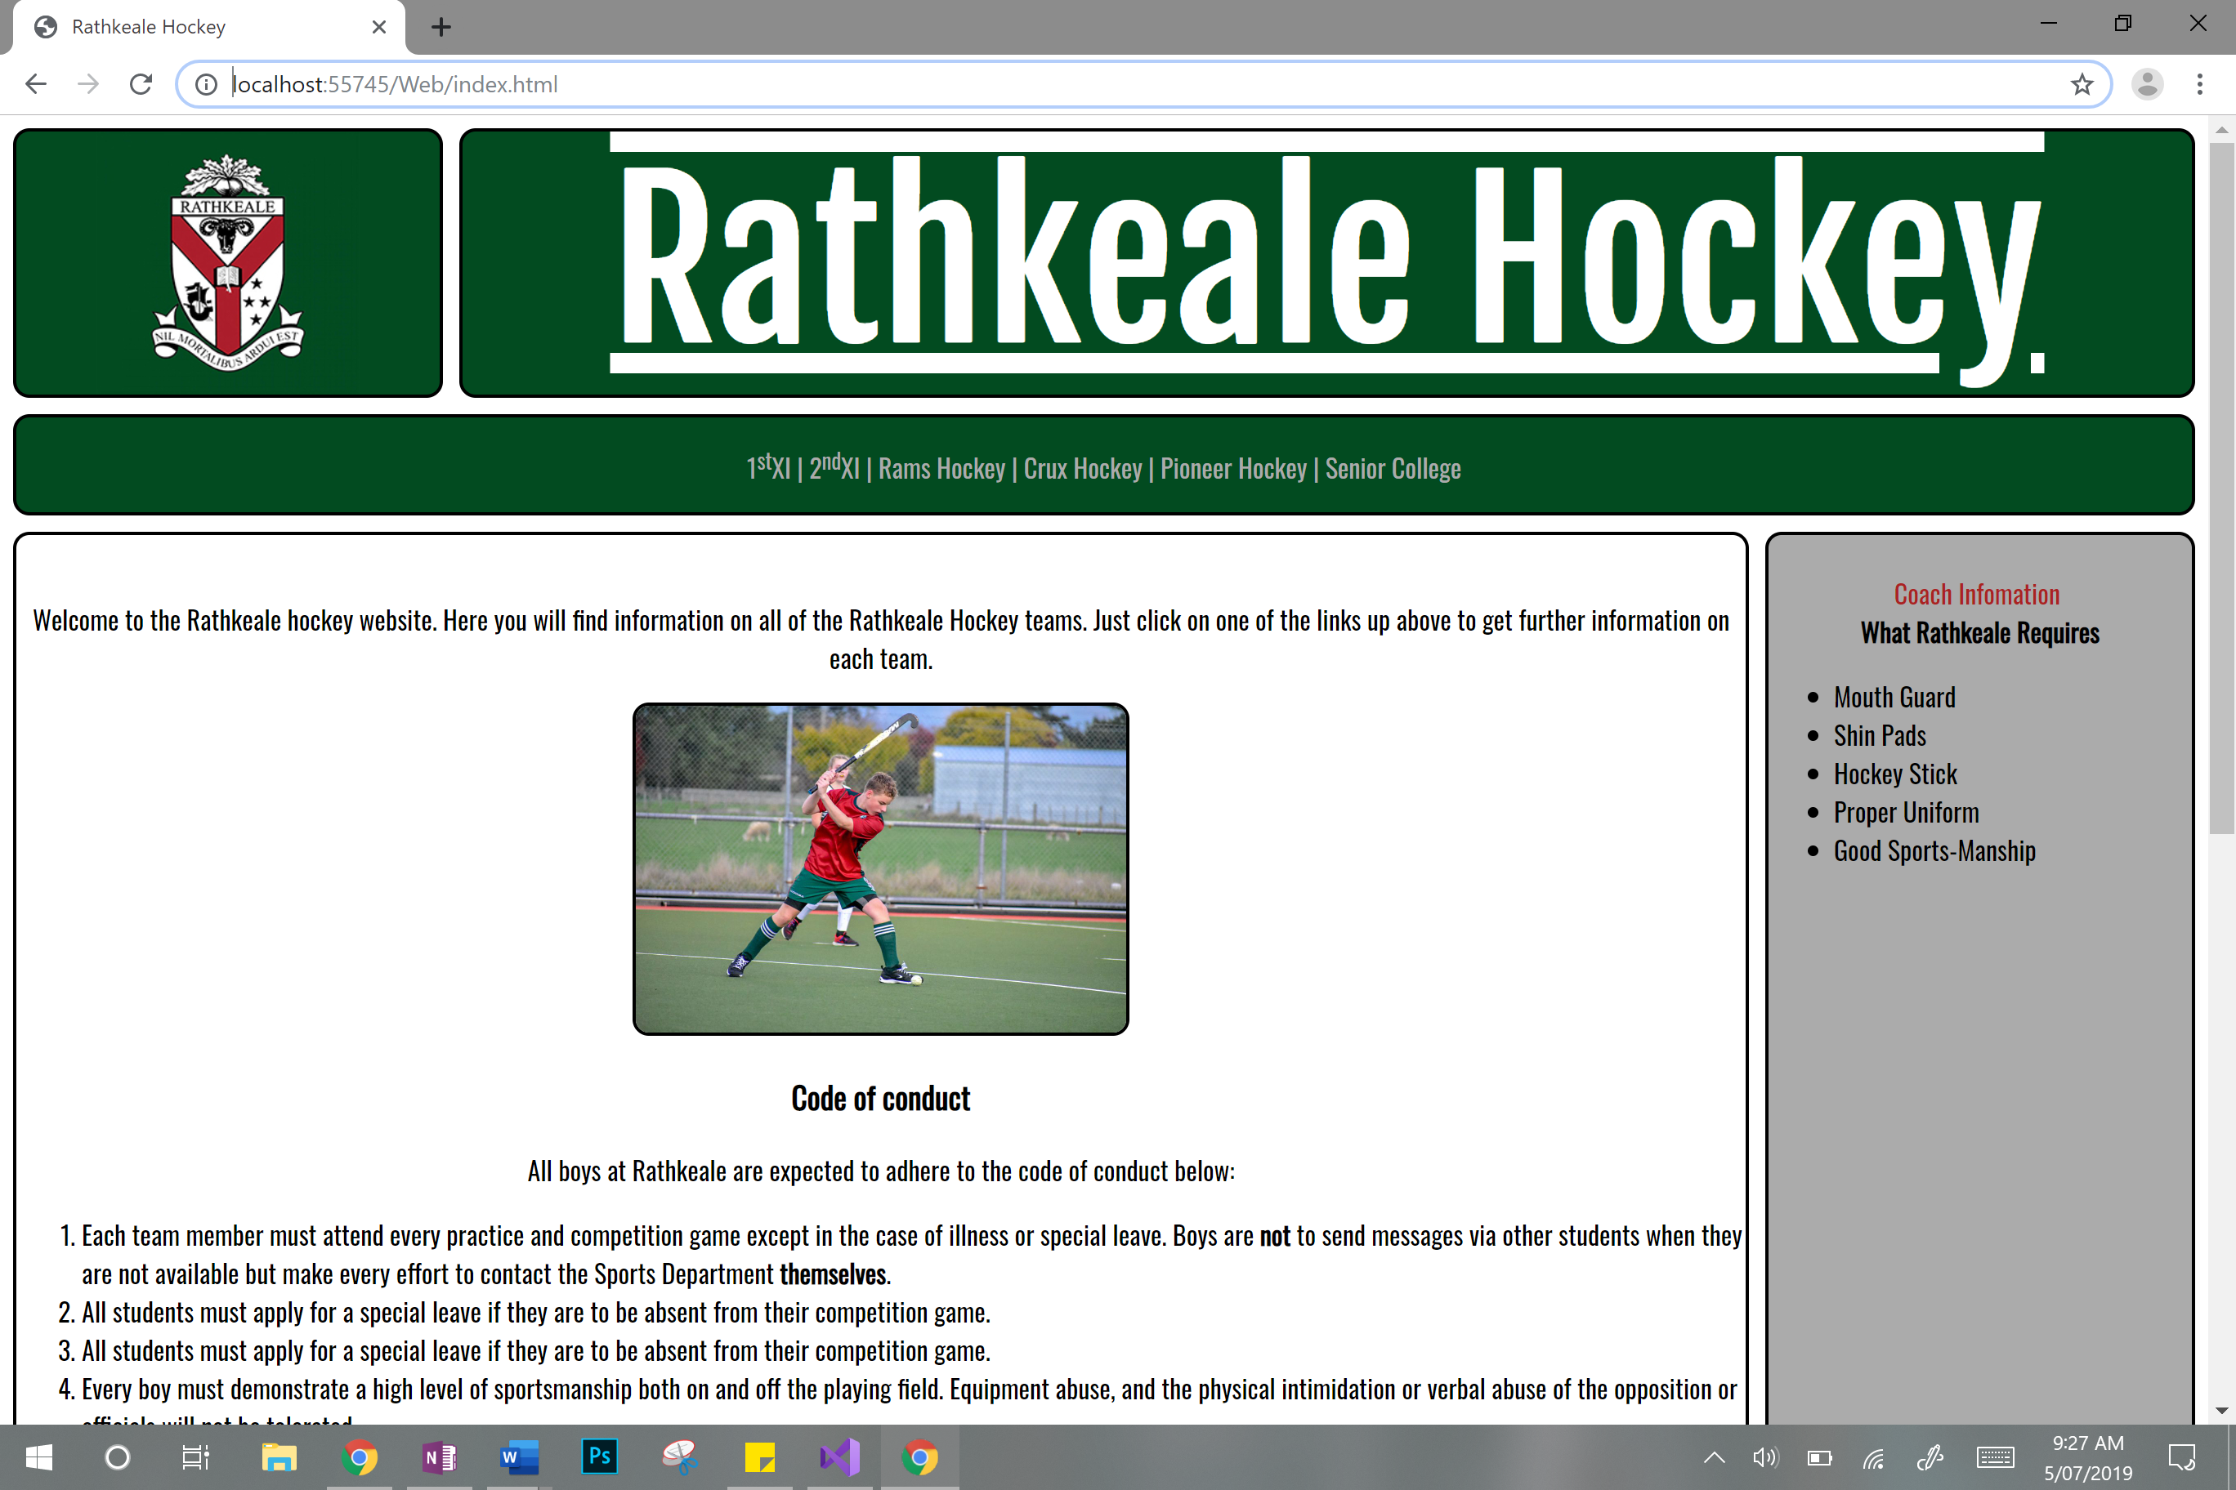

Edge:

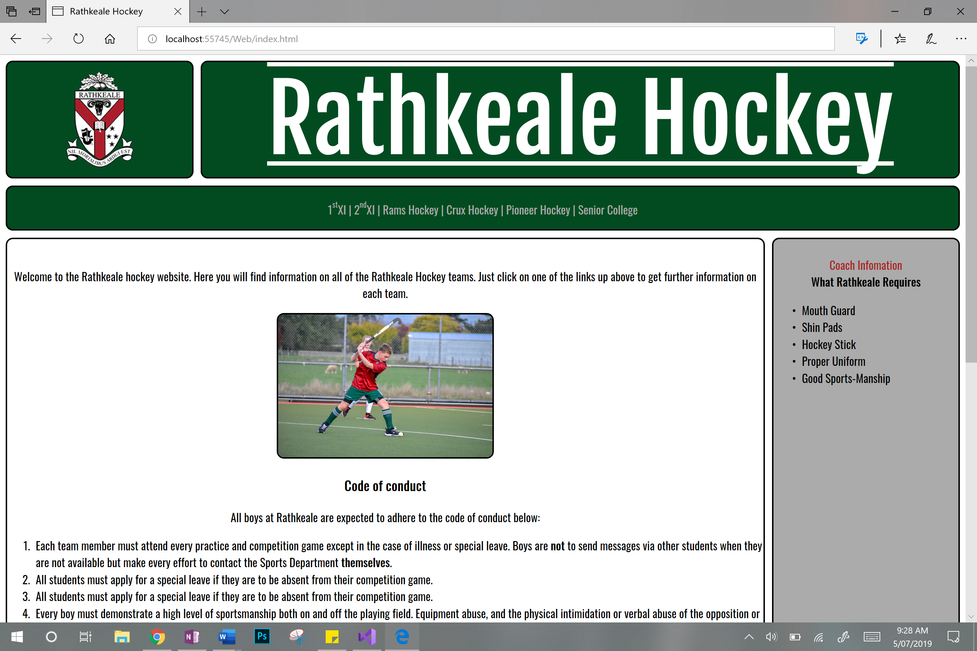

FireFox:

